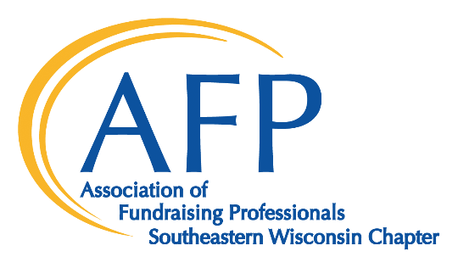

2023 National Philanthropy Day
November 15, The Pfister Hotel
Sponsor Commitment Form

I wish to be a National Philanthropy Day® sponsor at the ______________ level.

⃝ My check for $ __________ is enclosed.

⃝ Please bill me at the address below.

⃝ I am unable to attend, but enclosed is my tax‐deductible donation of $ ______________.

Company Name (as it will be printed in marketing materials) ____________________________

Contact: ____________________________________ Title: _____________________________
Address: ______________________________________________________________________
City, State, Zip: _________________________________________________________________
Phone/Fax: ____________________________________________________________________

E‐Mail: _______________________________________________________________________

Please return to:
Julie Cordero, Chapter Administrator
AFP SEWI
P.O. Box 511400
Milwaukee, WI 53203‐1400

Questions?
(414) 399‐0281
chapteradmin@afpsewi.org

Please reply by September 6 to appear on the event invitation.

