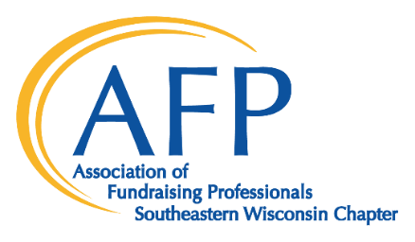
Celebrate National Philanthropy Day®
November 15, 2022
The Pfister Hotel

Sponsor Commitment Form

I/we wish to be a National Philanthropy Day® sponsor at the $__________ level.
_____A check payable to AFPSEWI for $_____is enclosed.
_____Please bill me at the address below.
_____I am unable to attend and enclosed a tax‐deductible donation of $____ to help celebrate.

Company Name (as it will be printed in marketing materials)
_____________________________________________________________________________

Contact Title

Address

City, State, Zip

Phone E‐Mail

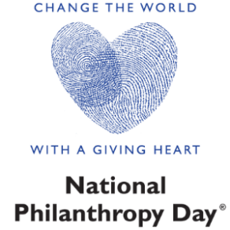
Please return to:
SIGN UP BY
SEPTEMBER 1
TO APPEAR ON THE
EVENT INVITATION
AFP SEWI
P.O. Box 511400
Milwaukee, WI 53203‐1400
chapteradmin@afpsewi.org
(414) 399‐0281
___________________________________________________________________________________ All sponsorships include name/logo with URL on AFPSEWI's NPD 2022 website plus:
Presenting Sponsor - $5,000
- Logo inclusion on event signage and multi-media presentations.
- Logo inclusion on in-kind print and digital ads.
- Opportunity for 3-minute presentation by an organization representative at event.
- Full-page color ad in event program.
- Priority seating - table of ten.
- Ability to leave promotional piece for attendees.
Platinum Sponsor - $3,500
- Logo inclusion on event signage and multi-media presentations.
- Logo inclusion on in-kind print and digital ads.
- Half-page ad in the event program.
- Priority seating - table of ten.
- Ability to leave promotional piece for attendees.
Gold Sponsor - $2,500
- Logo inclusion on event signage and multi-media presentations.
- Quarter page ad in the event program.
- Priority seating - table of ten.
Table Sponsor - $1,000
- Name inclusion in event materials.
- One table of ten.
Patron Sponsor - $500
- Name inclusion in event program.
- Four complimentary event tickets.

