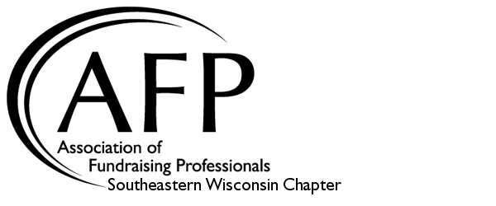
44th Annual
Association of Fundraising Professionals
National Philanthropy Day
2022 Nomination Form

- Nominee:

Name(s)

Organization

Address

Phone Email

- Award Categories:
Please check the appropriate award category. Descriptions of award criteria listed on the back of this page.

- Todd Wehr Volunteer Award

- Evan P. Helfaer Donor Award

- Wisconsin Organization Philanthropy Award

- Philanthropic Youth of Today Award

- Scott M. Cutlip Professional Fundraiser Award

- Qualifications:
To complete the nomination, please submit this form, a brief (one-page maximum) description of the person(s) or organization being nominated and up to three letters of endorsement. Please describe how your nominee qualifies for the award. Additionally, please list all volunteer and fundraising activities that you are aware of for your nominee.

- Submitted by:

Name

Organization

Phone Email

Submit completed nominations electronically by April 29, 2022 to:
Julie Cordero, Chapter Administrator, AFP Southeastern WI
Email: chapteradmin@afpsewi.org Phone: 414-399-0281
AFP - National Philanthropy Day Awards
Award Descriptions

Todd Wehr Volunteer Award: This award recognizes an individual or couple for sustained volunteer dedication in raising philanthropic funds in Southeastern Wisconsin
- Must be a volunteer fundraiser
- Demonstrated diversity and longevity of service
- Provided leadership in major fundraising efforts
- Obtained results judged to be significant in relationship to the wealth of the community and the support received
- Achieved success by involving others

Evan P. Helfaer Donor Award: This award recognizes an individual or couple for distinguished service in sharing resources with charitable organizations in Southeastern Wisconsin
- Donated substantial funds through current and/or planned gifts
- Exhibited diversity of giving interests
- Demonstrated commitment to multiple charitable causes
- Shown spirit of selflessness in the giving process

Wisconsin Organization Philanthropy Award: This award recognizes a corporation, foundation or organization with an outstanding record of philanthropic leadership in Southeastern Wisconsin
- Demonstrated leadership role in promoting philanthropy in Southeastern Wisconsin
- Encourages leadership and staff to participate in volunteer and/or philanthropic activities
- Developed innovative philanthropic programs
- Exhibited generosity in contributing and/or raising philanthropic funds

Philanthropic Youth of Today Award: This award recognizes a young person or group of young people who have made a significant difference in Southeastern Wisconsin through philanthropic leadership in the last year
- Philanthropic activity must have taken place when the nominee(s) is/are between the ages of 12-24, and within one year of nomination
- Groups nominated must be comprised of a majority of youth
- Philanthropic activity must be led and implemented by a young person/youth group
- Activity must demonstrate leadership, dedication, service and creativity
- An account of the philanthropic activity completed must be available (a non-family member must be able to vouch for the accomplishment of the youth)

Scott M. Cutlip Professional Fundraiser Award: This award recognizes a fundraising executive in Southeastern Wisconsin who has distinguished himself/herself professionally
- Ideally, the candidate is a member of the Association for Fundraising Professionals, but nominations will be considered for those who work for an organization with peers as AFP members
- Devotes full time or a significant proportion of his or her time to fundraising
- Exhibits proven track record of continued fundraising success
- Possesses a strong reputation as an ethical and respected fundraiser who exercises excellent stewardship of donor dollars
- Demonstrates volunteer participation for the profession and the community

